
ACE Tiverton
Family
Handbook




Welcome to Our Family Handbook.

This document is written with the aim of providing key information to all the families in our school community. It should be read alongside our website which includes all our key policies, procedures, and key information such as term dates. This is new document and will be revised and updated annually, in conjunction with feedback from our families via survey and the Family Forum.
If you wish to be involved in our Family Forum please come along to our meetings, which this year are:
September | Family Forum | Our Family Forums and Family Social Events are run by Mrs Stacy  Fagg Assistant Headteacher for Student and Family Support and  Sharna Causley our Student and Family Support Co-Ordinator. If you wish to come along or have an item, you would like discussed please contact them on: 01884763140 or email: sharna.causley@transformingfutures.org.uk
December | Family Social Event
January | Family Forum
March | Family Social Event
April | Family Forum
June | Family Social Event
Our school is part of the Transforming Futures Trust, based in Plymouth.
Transforming Futures Trust
Transforming Futures. Changing Lives. https://www.transformingfutures.org.uk/

Transforming Futures Trust works with students who find the traditional setting of a mainstream school does not best meet their needs. Our simple aim is to support the
development and improvement of the education for all pupils within the Trust and beyond
through school to-school support. Our extraordinary staff connect with our children and apply the principles of trauma informed care to enable them to reach their potential.
Transforming Futures Trust’s core aim is to create ‘positive futures for all’. We are building a culture of Trauma Informed Practice in all our schools which supports the wellbeing and development of all children and young people, Headteachers, School staff, parents/carers and stakeholders and the wider communities they are a part of. We have proven educational practice and strong leadership which has enabled us to develop new provisions across the southwest to meet the needs of children and families which have not been met in existing schools in the area. Since it was established, TFT has developed a highly effective internal capacity to support schools in their work.
with children and young people, helping them to make the biggest difference to their life chances.

In addition to ACE Tiverton School, there are three other schools in the Trust:

An alternative provision for children from 4-18 with sites across Plymouth, Cornwall, and Devon.

Based in Plymouth, Courtlands supports 100 primary aged children who have Moderate Learning Difficulties, Social, Emotional and Mental Health Difficulties (SEMH), and other complex needs.


Mount Tamar is an all through special school in Plymouth with a specialism in SEMH practice.

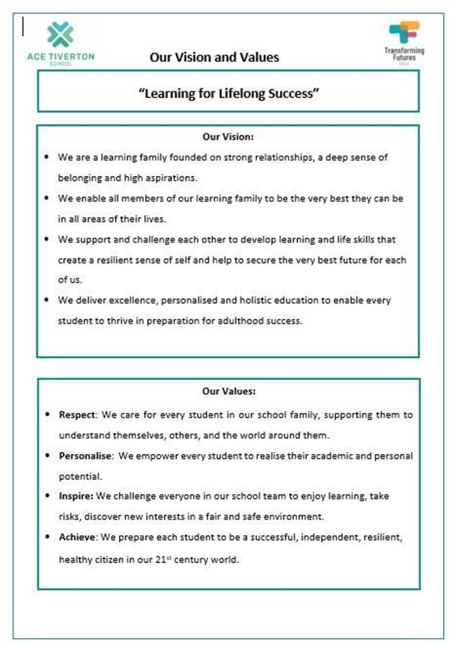
Listening to Views and Feedback:

The format of this handbook is structured around the frequently asked questions we hear from families, as well as feedback received through our half termly surveys. These surveys are very helpful in developing and improving the experience that families have – we send our surveys each half term to families, students, and staff via email.

As a new school community, we are keen to model our core values of respecting others’ views and experiences – using these to continual improve and refine our care and support of students, staff and the families that make up our wider school community.

Please take a few minutes each half term to share your views and let us know what is working well and what we can further improve.

School Development:
Each year, we have a focus on a small number of key priorities that have a positive impact on every student’s progression and development. This year, we are focusing on three key areas and all staff are working on these areas. By ensuring we are delivering excellent practice in these areas, we know that each student will have a better individual experience and make great er steps of progress in their academic, personal, social and wider development needs.
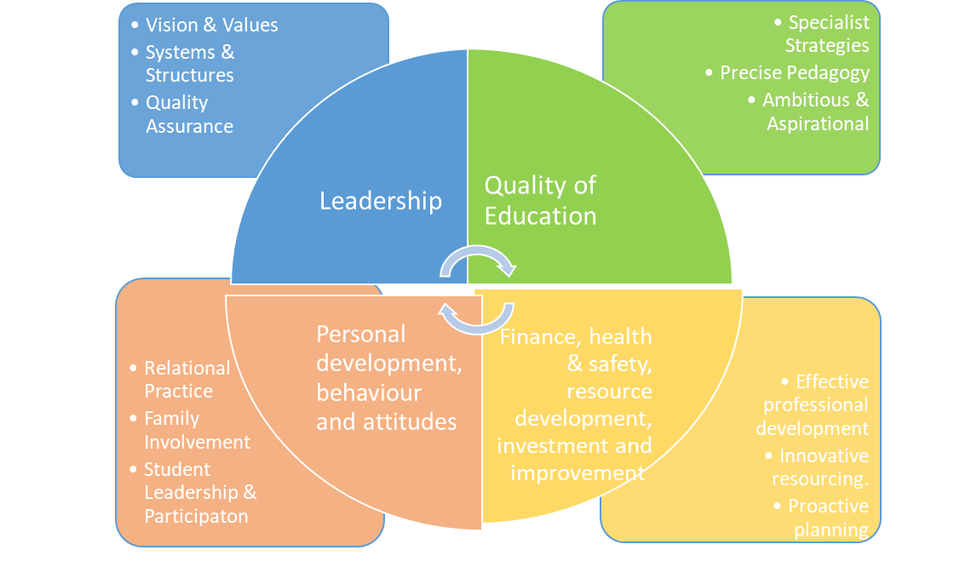
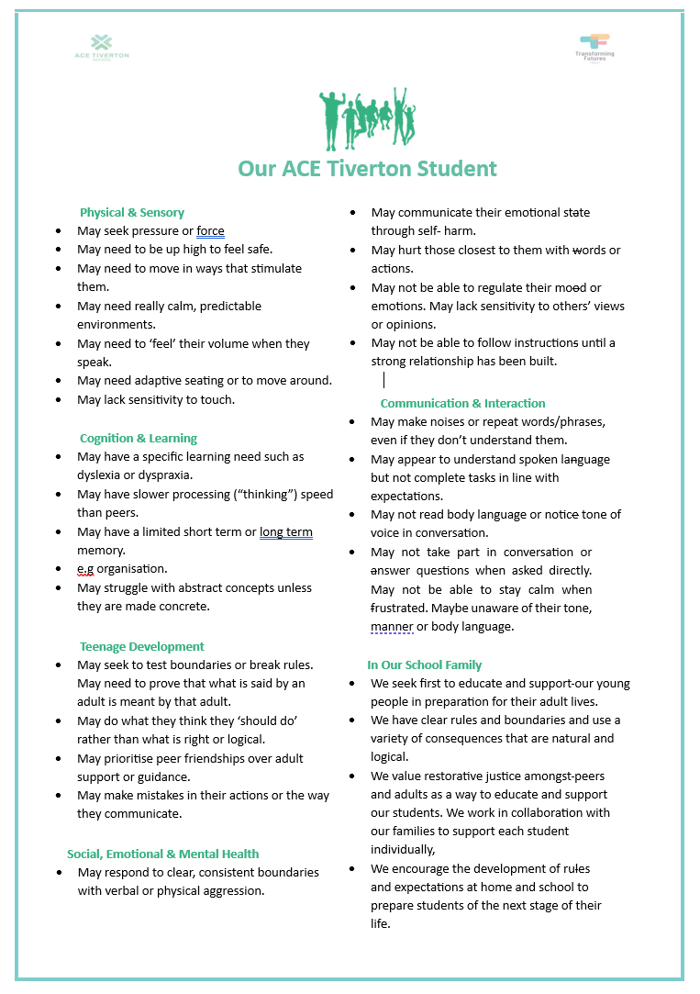
Our Core Offer:
We are a special school and all students who attend our setting have been assessed as appropriate for our core offer, through the 0-25 Team at Devon County Council. All our students are in receipt of an Education, Health and Care Plan and all have a range of needs across the areas of communication, interaction, social, emotional and mental health needs.

A full-time place at ACE Tiverton provides:
- A school day from 8am to 2pm that provides a range of social, academic and personal development opportunities to stretch, challenge and engage students with a range of educational needs and areas of interest.
- Students are taught in groups of between 8 to 10 based upon their learning levels, needs and social interaction skills.
- The timetable is built to enable access to sensory breaks, withdrawal space and adult support outside of the classroom as required.
- Specialist classrooms for secondary science, design technology, cooking and art are an integral part of our curriculum delivery.
- High expectations regarding learning and social behaviours with a focus on developing skills and strategies to thrive independently in a real-world setting.
- Social language and interaction strategies in the context of a cohort of pre-teen and teenage students with social communication needs linked to ASC alongside the challenge presented by puberty and teenage development.
- A regular and consistent input focused on wellbeing, physical and mental health, relationships, safety and citizenship is threaded throughout every curriculum area.
- Targeted provision to support students throughout their time at ACE Tiverton includes access to Talk Time, Breakfast Club, Student Leadership roles and the support of trained peer mentors.
- A broad and balanced curriculum that follows the national curriculum and KS4 qualification syllabi for all subjects offered.
- A personalised curriculum model that enhances skills, deepens knowledge and enables students to have a comprehensive range of qualifications, that prepares them successfully for adulthood.
- We teach students on a pathway to participate in mainstream post 16 learning, employment or training.
- A blended academic and therapeutic curriculum personalised to the needs of each student to include expert input from Occupational Health, Speech and Language Therapists, Educational Psychologists and Communication & Interaction Specialists.
- Therapeutic specialist environment and learning resources with all staff trained in de-escalation and specialist support strategies for students with additional needs related to an ASC diagnosis.
- We educate students in groups with a minimum adult/student ratio of 1:5.
- We make all possible adjustments to our physical environment and learning resources to meet the needs of students within the framework of the national curriculum and KS4 qualification requirements.
- Personalised and individual IT access for all students.
- If eligible, school transport is provided by Devon County Council.

What to expect from Learning Family Leaders:
A learning family leader is the equivalent of a tutor or form teacher. At ACE Tiverton, Learning Family Leaders have responsibility for the welfare, attendance, and progress of each student.
What is a Learning Family?
The Learning Family is the class in which your child is taught for most of their lessons, by a subject specialist Teacher and Teaching Assistant. Each Learning Family also has their own Teaching Assistant assigned to the group and they are present during the daily check in slots and Learning Family sessions.
How often will I hear form the Learning Family Team?
We expect a member of the Learning Family team to contact each family in their class at least weekly. This will be via the form of communication you express a preference for e.g., email or telephone call. Staff will also be in touch more frequently if needed and you are encouraged to speak to your Learning Family Leader with any questions, queries or concerns, we like to deal with issues early and act swiftly to prevent concerns from growing.
Will my Learning Family Leader change?
Except for staff who are leave or are absent and covered by another staff member, we aim to change Learning Family Leaders at the end as infrequently as possible. We may change the learning family your child is assigned to, in response to arising needs throughout the year.
How is a Learning Family group decided?
We group students based upon three core areas: stage of learning, profile of need and chronological age. Students join us with different educational experiences, and we consider their social, academic, and educational needs when placing in the group where they can make the best progress. We recognise that our students can struggle with social communication and interaction and alongside usual teenage challenges, there are a variety of interventions and support strategies we use to equip students with techniques to manage these.

Learning Family Group | Learning Family Leader | Learning Family Teaching Assistant
This is our staff list, and all staff have an email address as follows: Firstname.Surname@transformingfutures.org.uk.
Gadsby | TBC | Sarah Chatterton
Stoltman | Daryl Cargill | TBC
Applegate | Joanna Panton | Bryony Allen
Packham | Christine Radford/ Darren Sherwood | TBC
Kissin | Lucy Pike | Karen Stanley
Tesla | Kirsty McKinnon | Michelle Harrod
Burton | Sophie Bond | Jolie Harling
McGuiness | Kevin Morgan | Stephen Rowe
Mendoza | Amy Stanley | Izzy Bond
Brecel | Kathryn Botting | Kim Jones
Grandin | Ed Mountford | Rachel Bulley
Dawson | Ms Apps | Sue Bressington
Einstein | Ed Baker | Kirsty Bolton
Messi | Emma Coombes | Jude Graves

Leadership Team | ROLE | INITIALS
Mrs Hannah Smart | Executive Headteacher | HCS
Mrs Julie Chatterton | Head of School | JAC
Mrs Stacy Fagg | Assistant Headteacher – Student and Family Support & DSL | SAF
Mr Rhys Davies | Assistant Headteacher – Preparation for Adulthood | RTD
Mrs Nikki Macleod | Assistant Headteacher – Teaching and Learning | NM
Mr Adam Wray | Associate member of SLT – Data and Assessment | APW
Extended Leadership team | ROLE | INITIALS
Mrs Jo Panton | Nurture Co-ordinator – DDSL – Joint Applegate Learning Family Lead | JCP
Mrs Sharna Causley | Student and Family Co-ordinator & DDSL | SMC
Mr Leo Biles | Evidence for Learning - Learning Outside the Classroom Teacher | LCB
Mr Adam Wray | Science Teacher – Dawson Family Lead | APW
Mrs Kirsty McKinnon | English lead and Teacher – Tesla Learning Family Lead | KM
Miss Lucy Pike | Art Teacher | LAP
Teaching Team | ROLE | INITIALS
Mr Ed Baker | Mathematics Teacher & Einstein Learning Family Lead | EB
Mr Darren Sherwood | Pathway 1 Teacher | DS
Mrs Amy Stanley | Technology Teacher | AS
Mrs Kat Botting | English Teacher– Brecel Learning Family Lead | KB
Mrs Christine Radford | Pathway 1Teacher & Joint Applegate Learning Family Lead | CR
Mr Daryl Cargil | Pathway 1 Teacher & Stoltman Learning Family Lead | DC
Mrs Sophie Bond | Mathematics Teacher/History Teacher & Burton Learning Family Lead | SC
Ms Rhiannon Apps | Food Technology Teacher – Mendoza Learning Family Lead | RA
Mrs Amy Stanley | Design Technology Teacher & Mendoza learning Family Lead | AS
Mr Kevin Morgan | Health and Fitness Teacher | KM
Ms Emma Coombes | Pathway 1 Teacher & Messi learning Family Lead | EC
Teaching Assistant Team | ROLE | INITIALS
Miss Gemma Spence | Applegate (nurture) TA | GLS
Ms Kim Jones | Design and Technology TA – Brecel Learning Family TA | KJ
Mrs Catherine Ash | Science TA | CAB
Ms Siobhan Martyn | Food Technology TA | SM
Ms Kirsty Bolton | Maths TA – Einstein Learning Family TA | KB
Mrs Rachel Bulley | Humanities/1:1 TA – McGuiness Learning Family TA | RB
Miss Bryony Allen | 1:1 TA | BA
Miss Jolie Harling | Maths TA | JH
Miss Michelle Harrod | English TA – Tesla Learning Family TA | MH
Ms Sarah Long | Art/Science TA | SL
Mr Adrian Webber | 1:1/Btech Business TA | AW
HLTA Team | ROLE | INITIALS
Mr Steve Rowe | PE Coach – McGuiness Learning Family | SR
Family and Student Support | ROLE | INITIALS
Mrs Kate Davey | Family and Student Support & Assistant Head of year 7 | KD
Miss Roxanne Sargent | Family and Student Support Assistant& Assistant Head of year 8 | RS
Miss Amy Chatterton | Family and Student Support Assistant& Assistant Head of year 9 | AC
Administration Team | ROLE | INITIALS
Mrs Sarah Dunn | Lead Administrator | SD
Mandy Gomm | Administrator | MG
Mrs Nikki Orchard | Administrator | NO
Mrs Zoe Wheeler | Administrator | ZW
Delt Services Team | ROLE | INITIALS
Mr Jamie Troake | Caretaker | JT
Miss Leanne Allen | Cleaning Team | LA
Miss Roxie Saunders | Cleaning Team | RS
Miss Dharma Jonck | Cleaning Team | DJ

We operate a head of year system, to support students and families to address any concerns or access support.
Name | ROLE | INITIALS
Stacy Fagg & Sharna Causley | Head of year 7 | SAF & SMC
Kate Davey | Assistant Head of year 7 | KD
Stacy Fagg & Sharna Causley | Head of year 7 | SAF & SMC
Roxanne Sargent | Assistant Head of year 8 | RS
Stacy Fagg & Sharna Causley | Head of year 7 | SAF & SMC
Amy Chatterton | Assistant Head of year 9 | AC
Nikki MacLeod | Assistant Head of year 10 | NM
Juile Chatterton | Head of year 10 | JAC
Adam Wray | Assistant Head of year 11 | APW
Rhys Davies | Head of year 11 | RTD

What to expect from School Reports?
We track the progress of all students each half term in academic subjects as well as their EHCP targets. This information is collated and shared with families each half term.
What targets are set for my child?
We use the academic data from previous schools, alongside entry assessments in all subjects to inform our target setting. We set targets for the end of each key stage (KS3 = Y9 and KS4 = Y11) as well as the end of each year so you can see how your child is doing each term towards their yearly targets as well as their overall progress.
How do I know how my child is doing?
Each student is rated using red, amber and green colours for their progress each term, in every subject, as well as for elements of their school experience such as attendance and behaviour. Red indicates we are putting in place additional actions to support your child to make progress, amber tells you that we are monitoring your child’s performance closely and green indicates that all is as expected or better.
Should I expect everything to always be green?
Progress, in any subject or area is not achieved in a straight line. We know that our students will make progress with the right support and as needs are consistently met. It’s important to monitor progression as part of the students’ preparation of adulthood and development of EHC provision and targets to ensure that it accurately reflects students’ needs as well as to inform the planning and preparation of their teaching and support team too.
Who should I speak with for more information?
Your child’s learning family leader is your main point of contact for all queries and questions. They are the champion for your child and have access to the full range of details regarding academic, social and personal progress. We expect that staff will return calls and emails within 24 hours with email being the preferred method of contact for all staff.

We have three planned family evenings in this year, all from 3pm to 5.30pm which we run as hybrid events meaning that appointments are available in-person and on line.
Student Settling in Evening with Learning Family Leaders
Teaching Staff and Family Meetings
Learning Family Leaders End of Year Meetings

What to expect from Annual Reviews?
Annual Reviews are done throughout the year, linked to the date of the last review, as well as the date the EHCP was originally issued. Generally, Year 11 are done by October half term, Year 9 by Christmas, Year 8 and 10 before Easter and Year 7 after Easter.
How am I involved?
Students are at the centre of the Annual Review process, and we work with them to gather views. As well as, when they are ready, to lead and facilitate the review meeting. Families are asked to contribute and your presence at the meeting is important.
Who else will be there?
It depends on the progress and needs of your child. In short, we will invite all the people that are best placed to give us advice to improve the support and provision your child needs to make great progress.
Where is it held?
We can hold annual reviews in a mutually agreed location – offsite form school, via remote meetings or face to face in school time. We will work with you, the other attendees and your child to organise the most convenient time for everyone involved.
What else do I need to know?
All annual reviews are held using the EHCP Hub through Devon County Council’s 0-25 Team. If you don’t have access to the Hub, you can find out more here: Guidance for parents: Using the EHC Hub for an EHCP review - Education and Families (devon.gov.uk)

What to expect from specialist teaching and learning?
Our curriculum is based upon the ADPR framework, this enables us to align student’s needs as determined in their Education, Health and Care Plan to their future aspirations and goals. Overall, preparing our students to be productive, strong and independent adults is the primary goal of our curriculum. By achieving this, we will equip students to be successful, productive and valued members of their future personal, social, learning and employment communities.
How are staff trained to support students?
All classroom staff are given training and opportunity to further develop their own subject knowledge, specialist skills and understanding so they can support curriculum development and their colleagues throughout the school.
Do students have the breaks and resources they need in class?
Yes, absolutely – unless sensory and other needs are met, learning cannot happen safely and securely. Students have ready access and are adult directed and supported to use aides such as writing slopes, pen grips, wobble stools, fidget toys – all of these elements are normalised across the school, and everyone has their own personal profile of sensory support.
How are TAs used?
Teaching Assistants are key in delivering the personalised provision each student’s needs. Depending on the skill set and subject, TAs may be used for pre-teaching vocabulary, supporting comprehension and processing, keeping students focused and engaged or reviewing past learning to enable consolidation and retrieval to occur at a later stage. Teachers and TAs work closely together to plan, deliver, review and assess students’ progress within lesson and over time.
How are students assessed?
Students are assessed using a range of qualification frameworks in each year group. We recognise that our students have varying experiences of education prior to arriving at ACE Tiverton and we meet each student at the level that provides them with support and challenge to fulfil their potential. Specialist teachers and teaching assistants deliver in all subject areas.
If we need external support services to assess students, we work closely with families to gain consent and share the outcomes as well as using these to personalise our provision.
Curriculum Statement: “Learning For Lifelong Success”




Education, Health

& Care Plans

Preparation for

Adulthood

National

Curriculum

Qualifications

Curriculum.

Intent:
- Create a robust curriculum that empowers staff to be consistently excellent practitioners and ensures exceptional student progress in all areas of their development.
- Meet the outcomes and provision outlined in all students’ Educational, Health and Care plans within the context of a group education setting.
- Empower students by establishing secure routines that enable them to develop superb personal, social, and emotional skills.
- Deliver excellent support that ensures all students access appropriately challenging academic learning to achieve mastery of subject knowledge and be proficient in a wide range of skills that can be applied across the curriculum.
- Provide a structure that enables students to achieve appropriate qualifications that open doors to future earning and learning opportunities.

Overall Intention | Our Priority | Our Success
Quality &  Excellence | We will embed excellent teaching, learning and holistic student progress in all areas of our school community. We will secure a range of external qualifications and new experiences for every student in our school family. | We will know we are successful because students make concrete and measurable progress in their learning and development. We will know we are successful because students will be willing to participate in new experiences, take risks and be resilient to feedback.
Our Values | Implementation | Impact
Inspire | We will provide a wide range of formal and informal learning opportunities across our school family. | We will know we are successful because every person in our school family will talk confidently about their learning experiences.
Respect | We will integrate our all our students and staff successfully into our school family. | We will know we are successful because students can independently identify people, they have strong relationships with and the strategies they use to do this well.
Personalise | We will support our students to return to school routines, recognising the impact of the global pandemic and give our students space, time and strategies to process and understand the experiences they have had. | We will know we are successful because students will return to learning and report feeling safe, confident and secure in their routines and relationships.
Achieve | We will celebrate students’ progress in all areas by accurately assessing and monitoring their progress over time | We will know we are successful because students’ will show insight and understanding of their progress and how this contributes over time to their attainment in all areas.

Implementation: At ACE Tiverton, we offer a broad and balanced curriculum which builds on the knowledge, understanding and skills of all children, whatever their starting points, as they progress through each Key Stage. The curriculum incorporates the statutory requirements of the National Curriculum, within a three-year key stage three programme before moving to a two-year Key Stage Four curriculum that is framed by the requirements of external examination bodies. In all years and at all stages of learning, we provide a rich variety of other experiences which best meet the learning and developmental needs of the students in our school. The aim of our curriculum is for students to achieve mastery of the knowledge, skills and independence required for their next stage of learning as well as a strong foundation of lifelong learning, employment and success as a member of society.

Our philosophy is to provide a holistic, individualised approach designed to support students in fulfilling their potential. We have a shared vision to embed a nurturing and trauma informed approach throughout the school as we know that effective learning will take place when relationships are outstanding, staff are confident practitioners and students feel safe in their learning environment. The spiritual, moral, social, and cultural development of our students and their understanding of the core values of our society are woven through the curriculum.

Pathway | Curriculum Level | Curriculum Content | Group Number/Size | Curriculum Minimum Outcomes
Engage | Entry and Level 1 BTEC | English Maths Science Food Technology, Art, Design Technology, Prince Trust Project Based Learning, LOTC, Health and Fitness, Preparation for Adulthood, DEAR | 3 groups 6-8 students | Progress 3
Experience | Level 1 and 2 BTEC & Functional Skills/GCSE | English Maths Science Food Technology, Art, Design Technology, Prince Trust Project Based Learning, LOTC, Health and Fitness, Preparation for Adulthood, DEAR | 4 groups 8-10 students | Progress 5
Explore | Level 2 GCSE/Functional Skills & BTEC | English Maths Science Food Technology, Art, Design Technology, Prince Trust Project Based Learning, LOTC, Health and Fitness History, Business Studies, Preparation for Adulthood, DEAR | 5 groups 10 students | Progress 8
We deliver our responsibilities in PSHE, RSE, Careers and Citizenship through cross curricular thematic learning called ‘Preparation for Adulthood’. At the heart of this is teaching that enables students to become independent learners, prepared for adulthood and to explore their curiosity of the world. This does not happen immediately, we need to establish routines for learning that are consistent, this allows them to increase their confidence in their own ability as well as in the support you will provide. Our approach to teaching and learning enables us to focus on the needs of the students in each lesson alongside the skills and content their need to progress. Through personalised planning the resources used each lesson stretch, challenge and most crucially support students to make more rapid progress as learners.
Half Term | Core Theme | Pathway 1  Engage | Pathway 2  Explore | Pathway 3  Experience
1 | Being Me in My World | Me, Myself & I | My Relationship with the World | My Impact on the World
2 | Celebrating Difference | Being Independent | Equality for All | Empowering Others
3 | Dreams & Goals | My Potential | An Idea | Originality
4 | Healthy Me | Being Safe In My World | New Experiences | Mind, Body & Soul
5 | Relationships | Informed Consent | Togetherness | Love & Life
6 | Changing Me | My Progress | Self-Assessment | My Future
The outdoor environment and the local community are an opportunity for active learning for all our students and the school grounds have been developed so they can enrich different curriculum areas. Students have opportunities to share their learning with each other, their parents and carers and other learners regularly through the year. Developing their independence and motivation as learners and their sense of responsibility as future citizens is at the heart of all our teaching and learning.
Impact: We determine progression as the ability of students to:
Independence | Employ the skill or knowledge without reliance on an adult or peer.
Resilience | Use the skill or knowledge with confidence and show resilience when challenged.
Application | Relate the skill or knowledge in a range of contexts including other areas of the curriculum.
Consistency | Apply the skill or knowledge consistently across a wide range of subjects and tasks.
Synthesise | Organise ideas, making connections with other areas of learning and life.
Re-visit | Return to the skill or knowledge after a break and show that they can still use it without difficulty or to request support in remembering how or what to do.
Explain | Explain their skill or knowledge to another person and participate in conversation about it, ideally providing an assessment or opinion of the other person’s knowledge or performance.

Students are assessed using a range of qualification frameworks in each year group. We recognise that our students have varying experiences of education prior to arriving at ACE Tiverton and we meet each student at the level that provides them with support and challenge to fulfil their potential. Specialist teachers and teaching assistants deliver in all subject areas. All classroom staff are given training and opportunity to further develop their own subject knowledge, specialist skills and understanding so they can support curriculum development and their colleagues throughout the school. Whole school activities, thematic delivery, and opportunities within and outside school all enrich and develop students learning. Additional whole school programmes and approaches support quality first teaching and learning, and the school is well resourced in terms of learning materials, books, and technology.

Specialist Curriculum: Our school life and community is predicated on our core values: Respect, inspire and Achieve. This means that every interaction between students and staff is an opportunity to bring these to life and to model the social, communication, personal and interaction skills and knowledge that are central to securing ‘learning for lifelong success’. Our specialist curriculum is the foundation on which we layer our academic curriculum; without secure knowledge and skills relating to self, it is much more challenging to be a successful learner. Our specialist curriculum is the entirety of our students’ school experience – from prioritising relational practice and securing trust that needs will be met consistently and reliably in the classroom, to the therapeutic activities offered outside of the classroom, each element of a student’s learning is driven, through the provision outlined in the EHCP, to secure the very best Key Stage four achievements and post 16 provision possible. Further information can be found within our Student Support overview.

‘Preparation For Adulthood’ Curriculum: At ACE Tiverton we deliver our own strand to the curriculum called ‘Preparation For Adulthood’, aimed at broadening our students’ global outlook and building their cultural capital. It is made up of the following areas:
- Healthy Living (PSHE and Physical Wellbeing)
- Healthy Relationships (Relationships and Sex Education)
- Healthy Futures (Careers and Enterprise; Citizenship; British Values and Morals)
- Life Skills (Independent Living; Preparation for Adulthood; Cultural and Spiritual Capital)
- Mental Wellbeing - an ongoing theme that runs through all four of the above strands.
Programmes of study across all subjects will also outline how each unit connects with these areas, in addition to considering how to provide support and strategies in the four areas of need from the SEND Code of Practice:
- Cognition and Learning
- Sensory and Physical
- Social, Emotional and Mental Health
- Communication and Interaction
Curriculum Outcomes: Our specialist teaching staff design each programme of study to ensure full coverage of the national curriculum and preparation for GCSE and other appropriate formal accreditation in all subjects offered in our curriculum. Our subject offer and time allocation is as follows:
Subject Group | Subjects Included | Average Weekly Teaching Time
Subject Group | Subjects Included | KS3 | KS4
Core Subjects | English  Mathematics  Science | 2 hrs 15 mins per week per subject. | The curriculum in KS4 follows a similar time allocation as KS3 however as preparation for KS5 study, this may be supplemented by college or other vocational provision.
Foundation  Subjects | 3 hours per week (KS3)  - Preparation for Adulthood  - Humanities  2 hours 15 minutes per week (KS4)  - Humanities  - Business Studies |  | 1.5 hours per week per subject (7hrs 30mins in total)  - Design Technology  - Food Technology  - Health and Fitness  - Art
Foundation  Subjects | Learning Outside the Classroom |  | Overlay curriculum to meet needs of specific students and groups.
Specialist  Support | 30 minutes a day (2hrs 30mins in total)  Mentoring, Intervention and Therapeutic Support

ADPR Cycle: Our curriculum is based upon the ADPR framework, this enables us to align student’s needs as determined in their Education, Health and Care Plan to their future aspirations and goals. Overall, preparing our students to be productive, strong, and independent adults is the primary goal of our curriculum. By achieving this, we will equip students to be successful, productive, and valued members of their future personal, social, learning and employment communities.

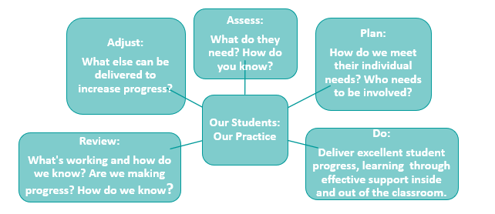

What to expect from the Relationship, Sex and Health Education Curriculum:
We follow the statutory national curriculum for Relationship, Sex and Health education (RSHE) as part of our Preparation for Adulthood curriculum which includes life skills and preparation for adulthood. We have three strands: Healthy Futures, Health Relationships and Healthy Living which covers all aspects of RSHE, careers and preparation for adulthood.
Who will teach my child these subjects?
As part of our staff team, we have a specifically trained group of staff who work together to deliver our Horizons curriculum. We use a range of resources that are tailored to the needs and profile of our students, taking account of their age and stage.
How will my child be taught these subjects?
We will use a range of specialist and subject resources and strategies to deliver the Horizons curriculum. Students will have time to process, ask questions and revisit topics that they wish to explore further. The wider staff team is also of the topic coverage for Horizons for each Learning
Family Class so as students raise questions or explore topics with peers, we
Can I withdraw my child from these lessons?
Adults with parental responsibility have the right to withdraw a child from the non-science aspects of sex education, within Horizons and this request must be made in writing to the Headteacher.
Where can I get more information:
The Department for Education: RSHE 2021 DfE Guide for Parents and Carers: DfE RSHE Guide for Families

What to expect in Preparation for Adulthood?
Preparation for Adulthood looks at and provides real world opportunities in areas such as employment, independent living, community participation, career aspirations, further education and friendships and relationships. Transition planning also thinks about transport needs, health care, personal care, living arrangements, and personal budgets. In essence Preparation for Adulthood is about ensuring that our young people are empowered practically and socially and emotionally to live full and rounded lives in which they are able to realise their ambitions and give back to the community in which they live.
We will ensure that all students are provided with access to and support for. The relevant outside agencies including Careers Southwest, representatives of which will meet with students, staff and parents and carers at key transition points; end of key stage 3 EHCP review and end of key stage 4
EHCP review.
When does it start?
Preparation for adulthood begins as soon as your child starts with us at ACE Tiverton. It is our aim and responsibility to help our young people realise their potential and follow their ambitions and dreams. Alongside academic and career focused goals we will support out students in developing their everyday life skills, manage real world situations and help them to discover what they can offer the community in which they live and attend school.
How Can I be involved?
We are always looking to widen the volunteer and work experience opportunities available to our young people. If you feel that you may be in a position to help us to do this by providing workbased experience, volunteering activities or know of others who may be able to help with this please contact: Julie.chatterton@transformingfutures.org.uk
In addition to practical experiences, we would also like to develop business and enterprise links within the local community. Links that will provide our students with the chance to develop and then implement basic business plans. Again any support or knowledge that you are able to share to facilitate this will be greatly appreciated and again please contact: Julie.chatterton@transformingfutures.org.uk
What opportunities are there before Y9?
The term preparation for Adulthood officially applies to Year 9 and above, however that does. To exclude Year 7 and 8 pupils from real world experiences and developing their life skills and knowledge of the world. This is done through the providing a wide range of experience and learning opportunities that broaden cultural capital, offer real world experiences and supporting students in developing and fulfilling their aspirations.

What to expect from safeguarding?
We take our responsibilities for the safety and welfare of our students very seriously. All staff received enhanced safeguarding training and we recognise that many of our students have increased vulnerabilities due to their profile of need and communication and interaction skills. We work closely with our Locality Teams and participate and lead on Early Help Assessments, Team Around the Family meetings as well as supporting our families who have more specific needs linked to child protection and safeguarding.
What does safeguarding cover?
In short, everything. The annual document, from the Department of Education called Keeping Children Safe in Education (KCSIE), is updated each year with the most relevant information and key issues that are emerging nationally, we work within this framework and our Safeguarding policy, on our website, gives more information on how we do this.
How do we educate students to be safe?
Our PfA curriculum is a significant part of our safeguarding strategy. We ensure students know how to keep themselves safe, where to get information and what is lawful, healthy and appropriate in a range of topics. We are fully compliant with the 2021 RSHE Statutory curriculum and the RSHCE policy on our website provides much more detail.
Does safeguarding mean contact with other agencies?
Safeguarding is a partnership between home and school – great communication helps both families and staff at school to understand the risks and worries that students may be experiencing Schools are asked to take the lead in a number of safeguarding areas – attendance, behaviour, early help are good examples. When we contact you to talk through a worry, it is not done with the intention to ‘refer on’ but to see what we can do to help. Our students come from across Devon and from a variety of personal and domestic situations – we make no judgement, we want the same as you – a safe, healthy, happy student, because they learn well and make the best progress, which is a great outcome for everyone!
What can I do as a parent or carer?
In this year’s KCSIE, there is a big focus on peer-on-peer abuse and online safety. These are two areas that our students can struggle with – seeing communication online out of context or misreading tone or intention. We have lots of resources on our website on monitoring student access to the internet and social media at home – we would ask all families to be proactive in morning social media and internet use and actively manage what your child is doing online.

What to expect from Physical Interventions?
All school staff, irrelevant of the setting in which they work, has the responsibility to work with students in a safe and appropriate way. The Department for Education guidance to schools outlines that reasonable force can be used to protect students from causing harm to themselves or others, to protect property from damage and to ensure the good order of a school.
Our school staff are trained in a wide range of de-escalation, regulation, and positive interaction strategies. Our approach, as a school community, is that behaviour is a form communication and we seek to understand the purpose, mechanics, and intent behind behaviours and work with students to develop health, appropriate and safe ways of expressing their emotions.
Physical Intervention is an act of last resort, but all staff are expected to use their training – starting with de-escalation – to support a young person in crisis. This may involve holds, guides or blocks to ensure that students are safe, and that good order is maintained across the school community.
What approach do we use?
As a staff, we are trained in Team Teach – this is a positive handling strategy that involves two days for training. The theory focuses on understanding the cause and mechanism of behaviours whilst increasing staff knowledge of trauma, sensory profiles, the neuroscience and emotional impact of behaviours on individual students as well as those who observe them or a focus on behaviours that challenge. The second day involves rigorous training on the physical interventions used, including holds involving one or two adults, moves that guide students and ways to block students from causing harm, upset or harm to themselves or others.
What happens if my child is involved in a physical intervention?
Any students involved in a physical intervention are given time and space to regulate with the most appropriate adult present and in the best space we can provide within the school - this will be individual for each student. When the student is ready, a debriefing conversation is offered and had which focuses on listening to their perspective of the situation and understanding what function the challenging behaviour was fulfilling for them in that situation.
A detailed reports is made of the intervention, within the shortest time possible, depending on the nature of the intervention and impact on the student, staff and wider school community. A student’s family will be informed by the end of the day in which the intervention occurred and as much detail as possible shared by the most relevant member of staff. The focus is on the care and support post-intervention for the student – as well as the staff involved too. Within an appropriate time, a restorative conversation will be held with the student and the member of staff undertaking the intention. The student can select the most appropriate adult to support them in this conversation.
What if this is a frequent event?
We review a student’s individual risk assessment each time a physical intervention is used. We track the number of interventions as well as the reasons for them, the mechanics of the behaviour and the function/response being sought. Where we need to, we will work with the student, their family and the most relevant member of school staff to write a Positive Handling Plan to ensure that all, relevant people, including the student themselves, understands what will happen, when, with whom and why, should there continue to be instances of challenging behaviour.
What else do I need to know?
Mrs Stacy Fagg is our lead for Team Teach. If you would like discussed please contact her on: 01884763140 or email: stacy.fagg@transformingfutures.org.uk
- More information about Team Teach: Team Teach – Training in positive behaviour management
- Our Positive Handling Policy: www.atss.acemat.uk/policies: Hyperlink: Positive Handling Policy
- More information about the Department for Education Guidance: Use of reasonable force in schools - GOV.UK (www.gov.uk)

What to expect from break and lunchtimes?
We run a comprehensive programme of activities throughout break and lunchtime but also provide students with space to decompress, chill out and have time to regulate away from others if needed. These include art and creative activities, supervised and structured play, board games, football, basketball and STEM activities.
What happens?
Students have access to all these activities and can make a daily choice about how they spend their time. After students have eaten, they can then participate in the activities on offer. All activities are supervised by staff, so it provides opportunities for students to build staff with staff across the school community.
Students who eat hot meals do so in our school dining room and students with packed lunches eat in our forum. We absolutely understand that many of our students have quite restricted palates and foods that they will eat. Our chef works within the information we gather from students and their families about preferences, allergies, tolerances and works with the School Food Standards to ensure each menu offers a range of food for students to eat as well as offering opportunities to taste and try new dishes with the aim of increasing their range of preferred foods over time.
How do I pay for lunch?
All families can set up a school money account that will enable you to pay online for all aspects of school life including trips, visits and lunches. Students can select their lunchtime meal and break snacks each morning with their learning family leaders during check in slots. Students who attend school trips will have a packed lunch provided, if they are entitled to Free School Meals. All students will have break snacks and drinks provided if off site.
School Food Standards
All food offered in schools, including packed lunches, must meet the School Food Standards. There is lots more detail about this on our website: ACE Tiverton School - School Food (acemat.uk)

What to expect from our Therapeutic Team?
Our Therapeutic Team of staff are specialist practitioners who we have sourced to provide staff with the most up to date and specialist training and guidance to ensure that every student is experiences the best possible support in all areas of the school experience. Our therapeutic team are all external practitioners – Occupational Therapist, Speech and Language, Counselling – who work across a variety of settings and within private practice too. This team supplements the Advisory Services that we can access through Babcock and Devon County Council.
Who are they?
Currently our Therapy Team consists of:
- Occupational Therapist
- Communication & interaction Clinic support
- Bounce: A Tiverton based Family Therapy Service
- School Counsellor (one day a week)
We are continually looking for additional Therapeutic support and work closely with Devon Support Services for Educational Psychology and Communication and Interaction Team input too. Consent for referral to Devon Support Services is gained on an individual student and service basis. The school-based Team have consent built into our school consents – trips, image use, data storage etc – and the universal consent given enables us to work quickly to source support as need is identified.
Can I refer my child to them?
All students in the school benefit from the Therapeutic Team as they train our staff in general and specific support strategies to meet the needs of our students. Additionally, we review EHCPs and ensure that all the provisions outlined in section F are being met within the daily experience of the individual student.
Occasionally, students may need highly specialised individual intervention, and this is accessed through the discussions had with the school staff and the individual Therapist. We always involve the student and their family in this discussion, especially where additional intervention is needed.
How do they work with staff?
Training, training, and more training! Whether as a whole staff group gaining deeper understanding into the broad concepts that influence our work with students or tailored, small group or individual training on a specific programme, our Teams – internal and external advisors – work with our staff to ensure they are confident and knowledgeable in what, how, when and why specific provision is required by students and how to deliver it to the highest possible standard.
How will I know if they are working with my child?
If a student is a specific focus or concern, the Learning Family Leader or member of the Student Support Team or Senior Leadership Team will be in touch. Often, you will be aware that we may want to talk through with a specific specialist to gather their views and possible consider observations or direct conversations with the student and their family.

At ACE Tiverton, we are trauma informed in our approach to all members of our school family, this means that:
- We connect before we correct
- We stay curious, not furious.
- We understand that behaviour is communication  We believe in co-regulation.
- We know that students regulate from the adults in their lives.
- We think “can’t” not “won’t”
- We empathise when someone is flipping their lid.
- We believe in restoration not punishment
- We know that excellent relationships reduce stress and build resilience for all.
- Resilience in our relationships means that we see you, we hear you and we are here with you.
- We are a learning family and all of us can assist one another to be the very best we can.

What to expect from Rewards?
Students can achieve three points in every lesson, check in and check out through meeting our expectations of the 3Rs – respect of self, others, and our environment. These points build up over time and can be used to purchase items from our reward shop.
How do students know what is in the shop?
Each half term, students are asked for ideas, suggestions, and their personal reward item for the term. They know what is available on a weekly, termly, and longer basis – if they have a bigger savings goal or if they prefer to purchase small items, regularly, both can be done.
The Student Voice meetings, which is held half termly, also has a regular item about the reward shop and other student led activities to increase their range of experiences skills and areas of interest.
What other opportunities does my child have at ACE Tiverton?
Every Friday, we offer a range of activities through our ‘Friday Elective’ Curriculum which staff run a variety of activities that students select and participate in for a term at a time. Trips and visits are a key part of our curriculum offer in addition.
What costs are there?
Activities Week in July, some of the activities on offer will come with a requested contribution for costs but this does not prevent students from participating. Other trips may also come with a request for contributions, and we work closely with families to ensure this isn’t prohibitive.
How do you celebrate progress?
Every half term ends with a celebration assembly and each ‘long term’ has a celebration to which families are invited. In addition, at the end of the academic year and at Christmas, we host Family Fun Events, where students and their families can participate in positive activities together and see the progress students make through their time at ACE Tiverton.

What to expect from students’ behaviour?
We know that all behaviour is a form of communication and in the context of a secondary school community where all students have significant needs relating to social communication, interaction, emotional and mental health in conjunction with the expected challenges of puberty and being a teenager, this is a factor for all students.
What approach do you take to behaviour?
Our values and approach to students is underpinned by a strong belief in trauma and therapeutic informed approaches. Students often develop maladaptive strategies to manage their emotions, reac-
tions and sensory needs. Whether internalised or externalised, each student is approached in the same way with empathy, curiosity and a desire to provide students with a healthy, safe and appropriate way to manage their communication.
Where can I find out more?
Our Positive Relationships policy in on our website, alongside our Behaviour Blueprint, both documents clearly outline the approach we take for all students. Proportional consequences linked to real-life contexts are a key tool, alongside de-escalation and restorative justice. We do expect families to work with us to support students and this is detailed ion our Family Relationship policy, also on our website.
What are the rules?
We have three clear rules: respect yourself, respect others and respect our environment. These rules are simply summarised by acting, speaking and responding in a way that is kind, appropriate or, at the very least polite. If this isn’t possible, then students are expected to use their personalised strategies to exit a situation, seek help and express their feelings in an appropriate place, with an appropriate person.
How does my child know what this means?
All rooms in school have our 3Rs visuals in them, in addition, every student has their own 5-point scale, which is a personalised tool to support students to respond to situations in the safest, healthiest and most appropriate way.
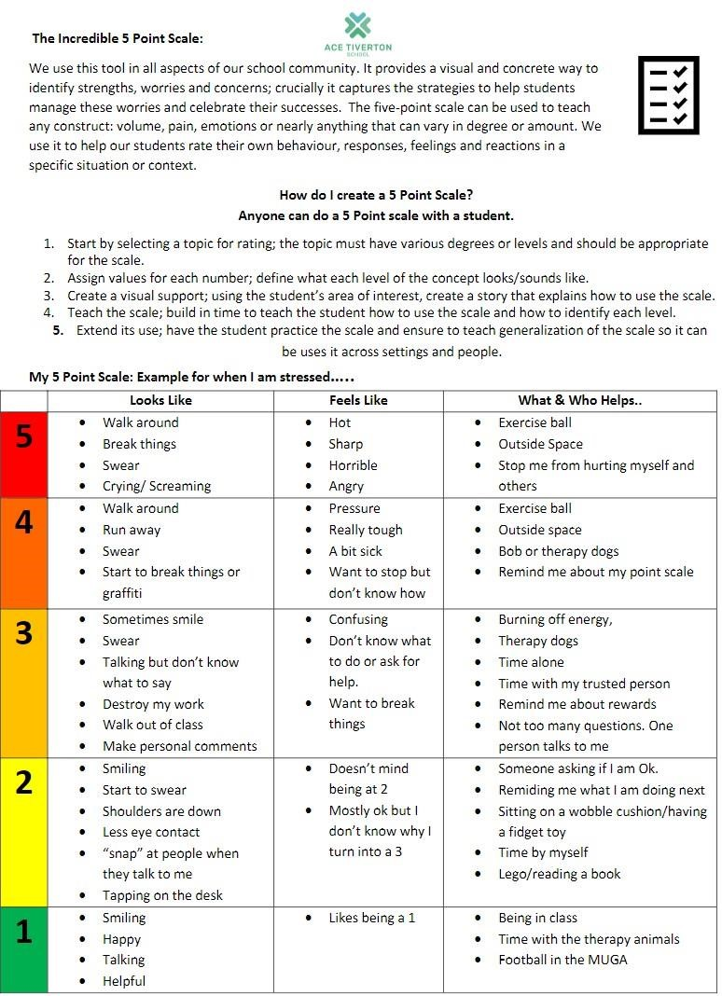
What to expect from a 5 Point Scale:

A 5 Point Scale is a concrete way of identifying abstract ideas and we use them in lots of ways across
the school community. Students are taught how to develop their own scales and they write one,
with a preferred adult. Scales are reviewed at least half t
ermly or sooner if needed.

Who does this with my child?

The short answer is that anyone can. The Learning Family Leader has responsibility for ensuring the
scales are completed and reviewed but they can be done by a family member, a preferred adult in
school or individually
–

how is best for the student. They a
re public documents and shared with all
staff, so they are a useful way for students to communities their views and preferences to all adults,
without having to speak directly with them.

What else is done with my child?

Every student has a risk assessment, one page profile and a 5
-
point scale. These are their standard
school documents, and they are shared with the student, their staff team and family, as they are de-
veloped and reviewed. If students need additional support

in any areas, we may also develop a posi-
tive support plan or personalised medical or handling plan to provide the specific information re-
quired to ensure students are best supported across their school day.

What to expect from Attendance?
We track all students’ attendance to school because we recognise the importance of great attendance in supporting student to make personal, social and academic progress.
What is ‘great attendance’?
Great attendance is the very best attendance each student can achieve. We expect all students to attend school 100% of the time but also recognise that to best meet students’ needs whilst they are with us, personalised attendance programmes may be helpful.
What happens if a student isn’t in?
Everyday a student is absent we contact home (known as a ‘first day call’). Depending on the reason for absence, the Learning Family Leader may be in touch to co-ordinate work or other support, members of the Student Support Team may be allocated to students whose attendance is causing concern and we work closely with the Education Welfare team to provide support for families too.
What happens if we have appointments?
We know that many of our students will be under the care of a range of medical and therapeutic practitioners. Absences for medical appointments are not penalised in anyway and we will work closely with each family to ensure students have access to work remotely, as required or in person to catch up on tasks and learning.
How do I let school know about planned absences?
Please email or telephone the school office with information about appointments or other absence information.

Term Dates 2024 - 2025
Term Number | Common Name | Start Date | Finish Date
Term 1 | Autumn 1 | Tuesday 3rd September 2024 | Friday 25th October 2024
October Half Term |  | Monday 28th October 2024 | Friday 1st November 2024
Term 2 | Autumn 2 | Monday 4th November 2024 | Friday 20th December 2024
Christmas Holidays |  | Monday 23rd December 2025 | Friday 3rd January 2025
Term 3 | Spring 1 | Monday 6th January 2025 | Friday 14th February 2025
February Half Term |  | Monday 17th February 2025 | Friday 21st February 2025
Term 4 | Spring 2 | Monday 24th February 2025 | Friday 4th April 2025
Easter Holidays |  | Monday 7th April 2025 | Monday 21st April 2025
Term 5 | Summer 1 | Tuesday 22nd April 2025 | Friday 23rd May 2025
May Half Term |  | Monday 26th May 2025 | Friday 30th May 2025
Term 6 | Summer 2 | Monday 2nd June 2025 | Friday 25th July 2025
Summer Holiday |  | Monday 28th July 2025 | Monday 1st September 2025
INSET Days | - Occasional Day Thursday 24th July  - Occasional Day Friday 25th July • INSET 1 Tuesday 3rd September.  - INSET 2 Monday 4th November – Disaggregated INSET (No Staff Onsite)  - INSET 3 Monday 6th January – Onsite INSET for all staff.  - INSET 4 Tuesday 22nd July – Onsite INSET for all staff.  - INSET 5 Wednesday 23rd July – Disaggregated INSET (No Staff Onsite)
Bank Holidays | - Christmas Day BH – Wednesday 25th December 2024  - Boxing Day BH – Thursday 26th December 2024  - New Year BH – Wednesday 1st January 2025  - Good Friday BH – Friday 18th April 2025  - Easter Monday BH – Monday 21st April 2025  - May Day BH – Monday 5th May 2025  - Late May BH – Monday 26th May 2025

School Day 2023 -24
Monday – Thursday
Time | Session
8am-8:15am | Learning Family Check In
8:15am-9:00am | Lesson One
9:00am-9:45am | Lesson Two
9:45am-10:15am | First Break
10:15am-11:00am | Lesson Three
11:00am-11:45am | Lesson Four
11:45am-12:15pm | Second Break
12:15pm-1:00pm | Lesson Five
1:00pm-1:45pm | Lesson Six
1:45-2:00pm | Learning Family Check Out

Friday School Day
Time | Session
8am-8:15am | Learning Family Check In
8:15am-9:00am | Lesson One
9:00am-9:45am | Lesson Two
9:45am-10:15am | First Break
10:15am-11:00am | Lesson Three
11:00am-11:45am | Lesson Four
11:45am-12:15pm | Second Break
12:15pm-1:15pm | Friday Electives
1:15pm-1:30pm | Learning Family Check Out

ACE Tiverton Uniform Expectations
Our students take pride in belonging to ACE Tiverton School; to help reinforce a focus on learning and to enhance the sense of belonging to our learning family, we expect all students to wear school uniform.
Our uniform rules are limited but reinforced through communication with the student, home and a focus on positive reinforcement linked to our Three R’s approach: respecting self, others, and our school community.
- We only allow approved hoodies from Stitch to Print. If a hood or cap is part of a student’s regulation strategy, part of our transition plan will be to reduce the reliance on this and find a suitable alternative from within our uniform options. Home - Stitch 2 Print UK
- We do not allow jeans, this is a conscious choice to support our students in preparing for adulthood and the demands of future learning, employment or training roles which require specific types of clothing to be worn.
- We do not allow logos as part of our student’s uniform. Items that make up a student’s school wear should be robust, easy to wash and be able to withstand the physicality of active learning. We do not want items of high value to be damaged while learning nor a reason for a student to not participate.
All items of clothing should be clearly marked with the student’s name. PE Kit should be kept in a clearly marked bag that can be kept in student lockers. As part of our school experience, we have non-uniform days. We aim to have one each half term and often we use these as part of our fundraising efforts for nominated charities. The expectations for non-uniform days are the same for school uniform days:
- Students are expected to dress appropriately for a school environment, this means being covered from neck to knee.
- Items worn should be suitable for the full range of activities students participate in as part of their timetabled day so items may get messy or worn outside.
- Items should not be expensive or of significant sentimental value as there is a risk that they may get lost or damaged as part of usual learning activities or school day routines.
- Students are responsible for their own items, and we provide students with a locker for the safe storage of their personal items.
- If you have any questions, please don’t hesitate to speak to your child’ learning Family Leader.
School Uniform |  | PE Uniform
Girls | Boys | Girls | Boys
Black skirt, Black trousers (No Jeans) | Black trousers, Black Shorts (No Jeans) | White polo shirt / Sports top | White polo shirt / Sports top
White polo shirt or White shirt | White polo shirt or White shirt | Black shorts/skirt/tracksuit bottoms | Black shorts/tracksuit bottoms
Cardigan or Jumper  Colour Options: Ash Grey or Jade  Blazer with logo | Cardigan, Jumper Hoody  Blazer with Logo | Jumper (No Logo) | Jumper (No Logo)
Black shoes or trainers | Black shoes or trainers | Plain trainers | Plain trainers

1 | If your ‘phone or any electronic item in seen in school, it must be handed in to ensure it is kept safely in an agreed place.
2 | We have a locked cabinet in which all ‘phones and electronic items are kept. This is the safest place in the school for all electronic items.
3 | If another place is agreed, this will be recorded on your five point scale.
4 | Phones and other electronics cannot be checked or used throughout the day, unless agreed as part of a personalised support plan. These will have very specific reasons and a limited time that they apply.

We recommend students don’t bring in any item that is of value or importance as there is a risk is may get lost or damaged in a busy school environment.

Every student has access to a locker and this is the safest place to keep non-electronic items.

School Rules: Mobile ‘Phone & Electronics



