

Fire, Lockdown & Emergency Evacuation Procedures

Updated for Academic Year 2026-27

Fire Plan 2026-27

The following steps must be taken in the event of a fire drill, fire alarm or Lockdown drill/emergency. All staff are expected to carry a radio and be on channel one. The assembly point for the school site is at the front of the building, students will line up in alphabetical order, in front of their learning family leader, with the TA supporting.

Role | Action
Administration Team | - Admin Team to gather student and visitor registers for checking, hand out student registers to the Learning Family Lead.  - A member of the Admin team to take the visitor register and report any missing visitors to the Lead Administrator.  - Take the office mobile phone and student contact list including any medications required (all contained within the Evacuation Go-Bag).
Learning Family Leaders/  Class Teacher | - Leaving all personal belongings, evacuate your class to the front of the building.  - Leave by the NEAREST fire exit. (See table on page 2)  - Meet your learning family in the designated space, line them up and take the register & confirm complete by raising the ‘Red & Green’ sign given out with the registers.  - Report any missing students to Executive Head Teacher, Head of School or the SLT member of staff in charge.  - Learning Family Leads/Class TAs are responsible for taking the registers.
Teaching Assistants | - Support with evacuating your class.  - Collect the student register from The Admin Team located at the front of the car park & return once complete.  - Support by actively managing the line of students, reassuring and keeping them calm.
Fire Wardens | - Sweep your designated area of the school building, unless it is clearly too dangerous to do so.  - Report your findings to The Assistant Head for Teaching & Learning or the Lead Administrator at the fire panel site. A member of the Admin Team to be backup if the Lead Administrator is not onsite.
SLT  Assistant Headteacher for Student & Family Support acts as cover for any absent staff member with a role in the evacuation process | - Assistant Headteacher: Position at front of school site to co-ordinate the evacuation of students, collate registers and identify any missing students and communicate with the Executive Head or Head of School to inform the Fire Brigade.  - Lead Administrator: Position at the Fire Panel to co-ordinate the Fire Marshalls and collate their findings with the Executive Head/Head of School, to communicate with the Fire Brigade and alarm monitoring company. As soon as possible, inform Trust Leadership (Regional Director) or the Trust Emergency Line. If unavailable, the Executive Headteacher must be informed.  - Executive Headteacher/Head of School will call the fire brigade in the event of a suspected or confirmed, real fire. They will be placed between the student lines and the fire panel to prevent re-entry to the building until all is declared safe. This person will declare the building safe to re-enter or invoke the next step of the critical incident protocol.
Visitors | - All visitors will report to The Admin Team at the front of school; as part of the dynamic risk assessment of the incident, visitors may be moved to the grass area opposite the school driveway.
Site and Catering Team | - Evacuate to the front of the building, onto the grass space immediately opposite the school driveway to ensure safe management of students with the school site boundaries.
Haven | - Haven staff are not permitted to park alongside the play area side fence in the front car park. Designated, marked spaces are to be used only.  - The Haven building will ONLY evacuate if instructed by the lead senior member of staff overseeing the evacuation.  - Leave all personal belongings and leave by the closest fire exit.  - Gather in the front at the furthest point from the building. If required, the grass area outside of the car park can be used.  - Haven contact order: Fire Warden – Class Teacher – Orchard Admin Staff - SLT  - A member of SLT will bring the evacuation list to Haven.  - The Haven Lead Teacher will be the contact between Haven & Orchard sites.  - The Stoltman Learning Family Teacher will Support to students with PEEP  - Haven teachers are responsible for taking the registers.

AREA | NEAREST FIRE EXIT
GYM, STUDENT SUPPORT, FOOD TECH | LOTC GARDEN FIRE EXIT
DT | WALKERS GATE FIRE EXIT
DINING HALL CLASSROOM | DINING HALL FIRE EXIT
ART CORRIDOR | MUGA FIRE EXIT
ENGLISH CORRIDOR | SENSORY GARDEN FIRE EXIT
SCIENCE, STAIRS CLASSROOMS | WALKERS GATE FIRE EXIT
PACKHAM, BRECEL | REAR STAIRS FIRE EXIT

Staff are expected to exit the building, during any fire or emergency evacuation by the closest route to their current location, without re-entering the building. This may involve accessing the rear car park and using the pavement around the school to reach the assembly area.
Every member of staff is a Fire Warden.
Class Teachers are to evacuate students to the designated area. Teaching Assistants are to sweep the building and complete the Fire warden checks.

Fire Location Plan

All locations are from the front of school, looking from the vehicle access point. It is imperative the school drive is kept clear to enable access for emergency vehicles.
Role | Assigned Location
Learning Family Groups | - 1: McGuinness – Top Left  - 2: Brecel – Second Left  - 3: Dawson – Third Left  - 4: Mendoza – Fourth Left  - 5: Kissin – Fifth Left  - 6: Grandin – Top Right  - 7: Tesla – Second Right  - 8: Einstein - Third Right  - 9: Packham – Fourth Right  - 10: Burton – Fifth Right  Where staff are not linked to a Learning Family, the support and are directed by the Assistant headteacher in organising learning family lines and collecting registers, establishing any missing students or staff.
Individual Student Evacuation Plans | PEEPS – Lead for PEEP, class teacher with back up as Teaching Assistant. SLT Lead. Named PEEP person to report to Lead Administrator  All PEEP leads to leave by nearest fire exit.  - Packham – T. Troake PEEP - Teegan 26.docx S. Graham PEEP - S Graham 040926.docx  - Dawson – E. Stewart - PEEP - Erin Sep 26.docx  - McGuinness– G. Stevens - PEEP - Graycie 2026 (1).docx evacuation sheet to be used if upstairs. Also to be use if in seizure. 1:1 & class teacher to action with SLT lead.  - Stoltman – C. Coleman - PEEP Charlie C- 2026-2027.docx Z.Cottrell - PEEP Zack C- 2026-2027.docx D.Gill - PEEP Daisy G- 2026-2027.docx  - Mendoza – M. Stark Millie Personal Emergency Evacuation Plan.docx  - Grandin – R. Becroft Rhys Beacroft PEEP.docx R Boardman  - Applegate – T.Duncan PEEP Tilly D Sept 26.docx G.Stamp - PEEP George S Sept 26.docx  - Brecel J. Andrews PEEP - Joey A.docx  - Einstein A. Smith Aston Smith PEEP.docx  Copies pinned to Evacuation list in main office.
Teaching Assistants | In the first instance, TAs join their learning family. Where TAs are not assigned to a learning family, support alongside the Student Support Team in settling students and taking registers.
Student Support Team | Once Fire Warden sweeps have been completed and results reported to the Lead Administrator, Student Support Staff should support their assigned learning family groups.
Administration Team | The administration team should base themselves away from the building between the Learning Family lines and main reception. All visitors should report to the administration team to be signed in and confirmed as safe.
Visitors | All visitors will report to the administration team at the front of school; as part of the dynamic risk assessment of the incident, visitors may be moved to the grass area opposite the school driveway.
Site and Catering Team | Evacuate to the front of the building, onto the grass space immediately opposite the school driveway to ensure safe management of students with the school site boundaries.
Senior Leadership Team  Assistant Headteacher for Student & Family Support acts as cover for any absent staff member with a role in the evacuation process | - Assistant Headteacher for Teaching & Learning: Position at front of school site to co-ordinate the evacuation of students, collate registers and identify any missing students and communicate with the Exec Head / Head of school to inform the Fire Brigade.  - Assistant Headteacher for Student & Family Support: Position at the Fire Panel to co-ordinate the Fire Marshalls and collate their findings with the Executive Headteacher/SLT Lead to communicate with the Fire Brigade and alarm monitoring company. As soon as possible, inform Trust Leadership (Regional Director)  - Executive Headteacher/Head of School: This person will call the fire brigade in the event of a suspected or confirmed, real fire. They will be placed between the student lines and the fire panel to prevent re-entry to the building until all is declared safe. This person will declare the building safe to re-enter or invoke the next step of the critical incident protocol.
As with any critical incident, a dynamic risk assessment will be undertaken by the lead member of staff (Executive Headteacher/Head of School). Whilst this is the published plan, to ensure the safety of all members of the school community, adaptions may be made in response to situation specific events that arise.

 Lockdown Procedure 
Signals
Alarm or signal for lockdown/shelter in place | Radio Lockdown x 3
Signal for stand down/all-clear | Radio All Clear x 3

Incident Control Officers & Response Team
Role | Name | Emergency Contact Number
Incident Control Officer | Hannah Smart  Julie Chatterton | 07395798129  07395798135
Deputies | Nikki MacLeod  Rhys Davies  Sarah Dunn | 07897399199  07568428657  07368 608287
Communications Officer | Stacy Fagg | 07915070982

It is important to remember that it is very much the exception to evacuate a building in the event of a hostile intruder. Unless the location of the intruders is known, a "blind" evacuation may be putting people in more danger (e.g. from an intruder or device at one of the entrances/exits) than if they had remained within the building.

Rooms most suitable for lockdown
1 Classroom – away from windows and doors, using cupboards, where safe and suitable.
2 Quiet Zones
3 Office Spaces (excepting the main office)

It is important to make sure that items that could be used as weapons (kitchen implements, sports equipment, tools, cleaning products) are securely locked away when not in use.

Communication arrangements
Wherever possible use silent communications and keep noise to a minimum especially if the intruders are close by. Make sure any communications devices are secure and cannot be intercepted.
Radios
Mobile phones – if available
Instant messaging / email – use of personal devices is permitted for this instance

Other useful contacts:
Name | Emergency Contact Number
Emergency Services | 999
Hannah Smart | 07395798129

Action Plan | Completed by (sign and time)
Sound Alert - Activate lock-down procedures immediately
SAF to dial 999 and ask for the police on direction of JAC or HCS.
Named Deputy (JAC) to confirm at point of lockdown to contact HCS if not onsite.
Direct all children, staff, and signed in visitors to the nearest safe place (this may be dependent on what and where the risk is)
Secure rooms and take action to increase protection from attack – Cover, Lock and barricade doors and windows where possible.
Close windows / blinds
Turn off the lights, smart boards, fans or mobile air conditioning units (this will reduce noise and the risk of exposure to any chemical/biological attack)
Move to the most appropriate and nearby space, inside a classroom, quiet zone, office - away from windows and doors
Stay as silent as possible - put any mobile devices to silent
Teachers are leaders in the room. Where there is no teacher present, the most senior member of staff (team leader, extended leadership member, longest serving staff member) ensures that students, other staff and visitors are aware of an exit point in case the intruder does manage to gain access
If possible, check for missing / injured students, staff and visitors
Keep doors and windows locked shut and remain inside until an all-clear has been given by a member of SLT, or unless told to evacuate by the emergency services

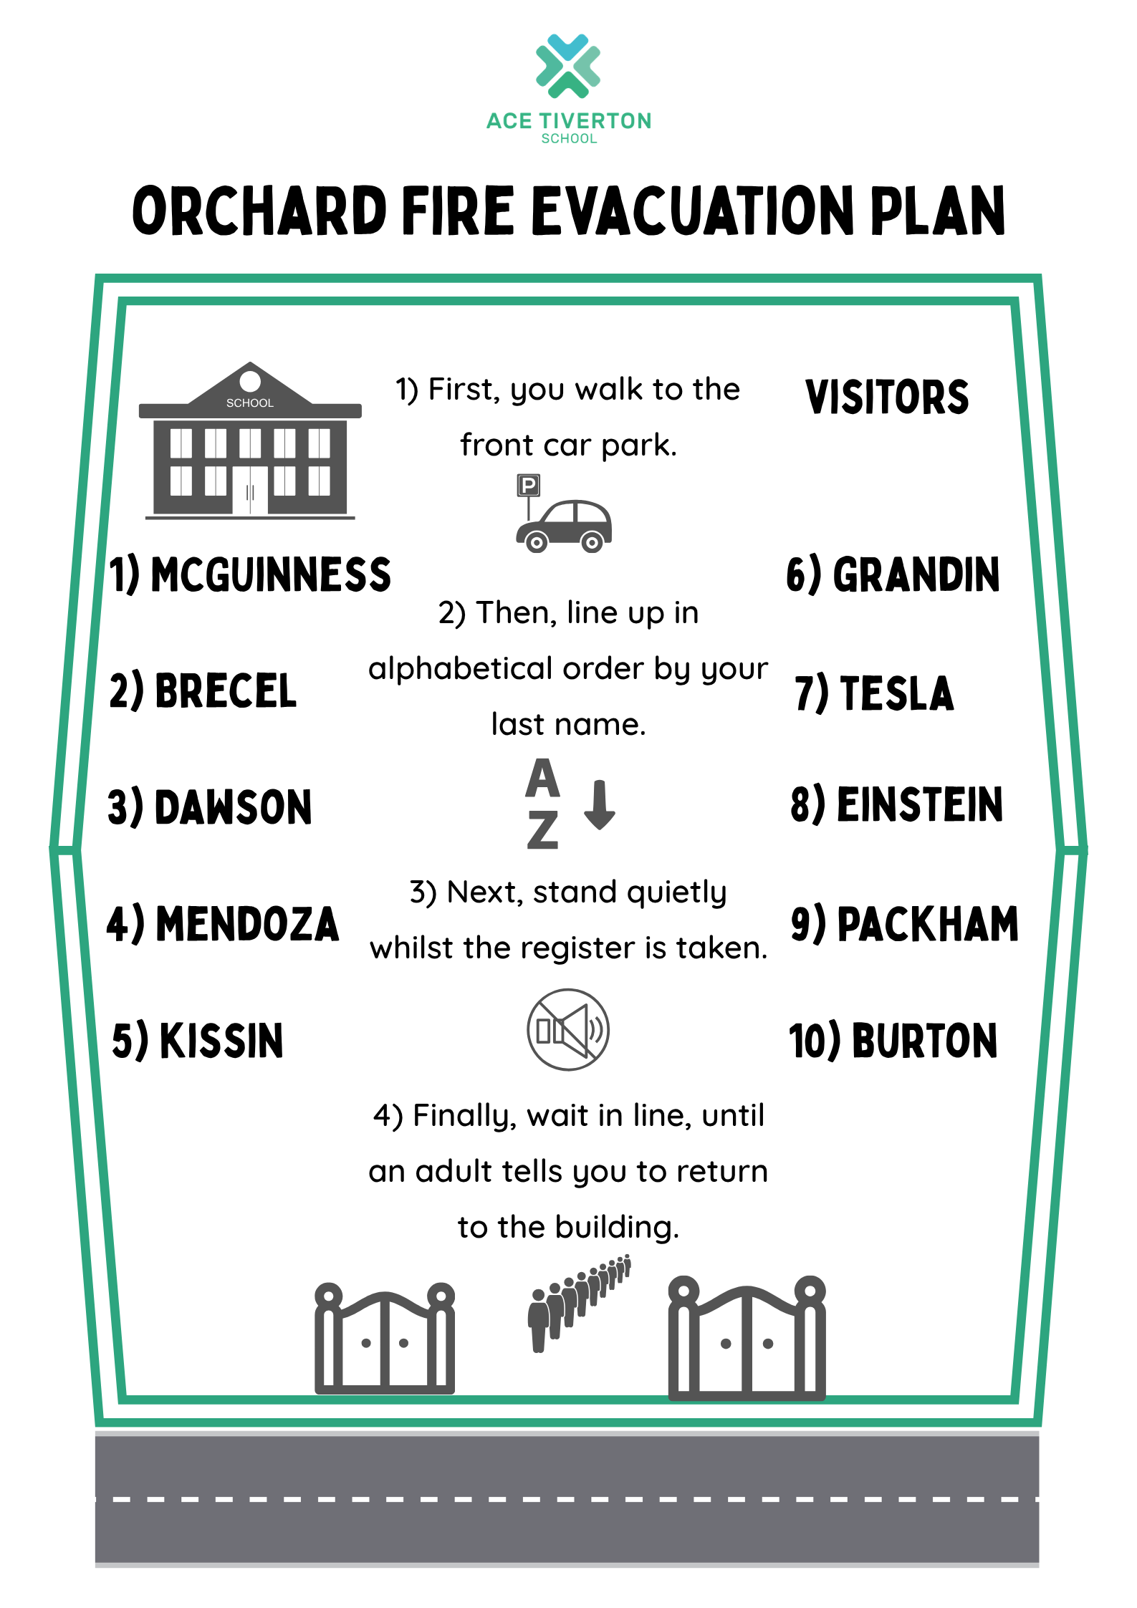
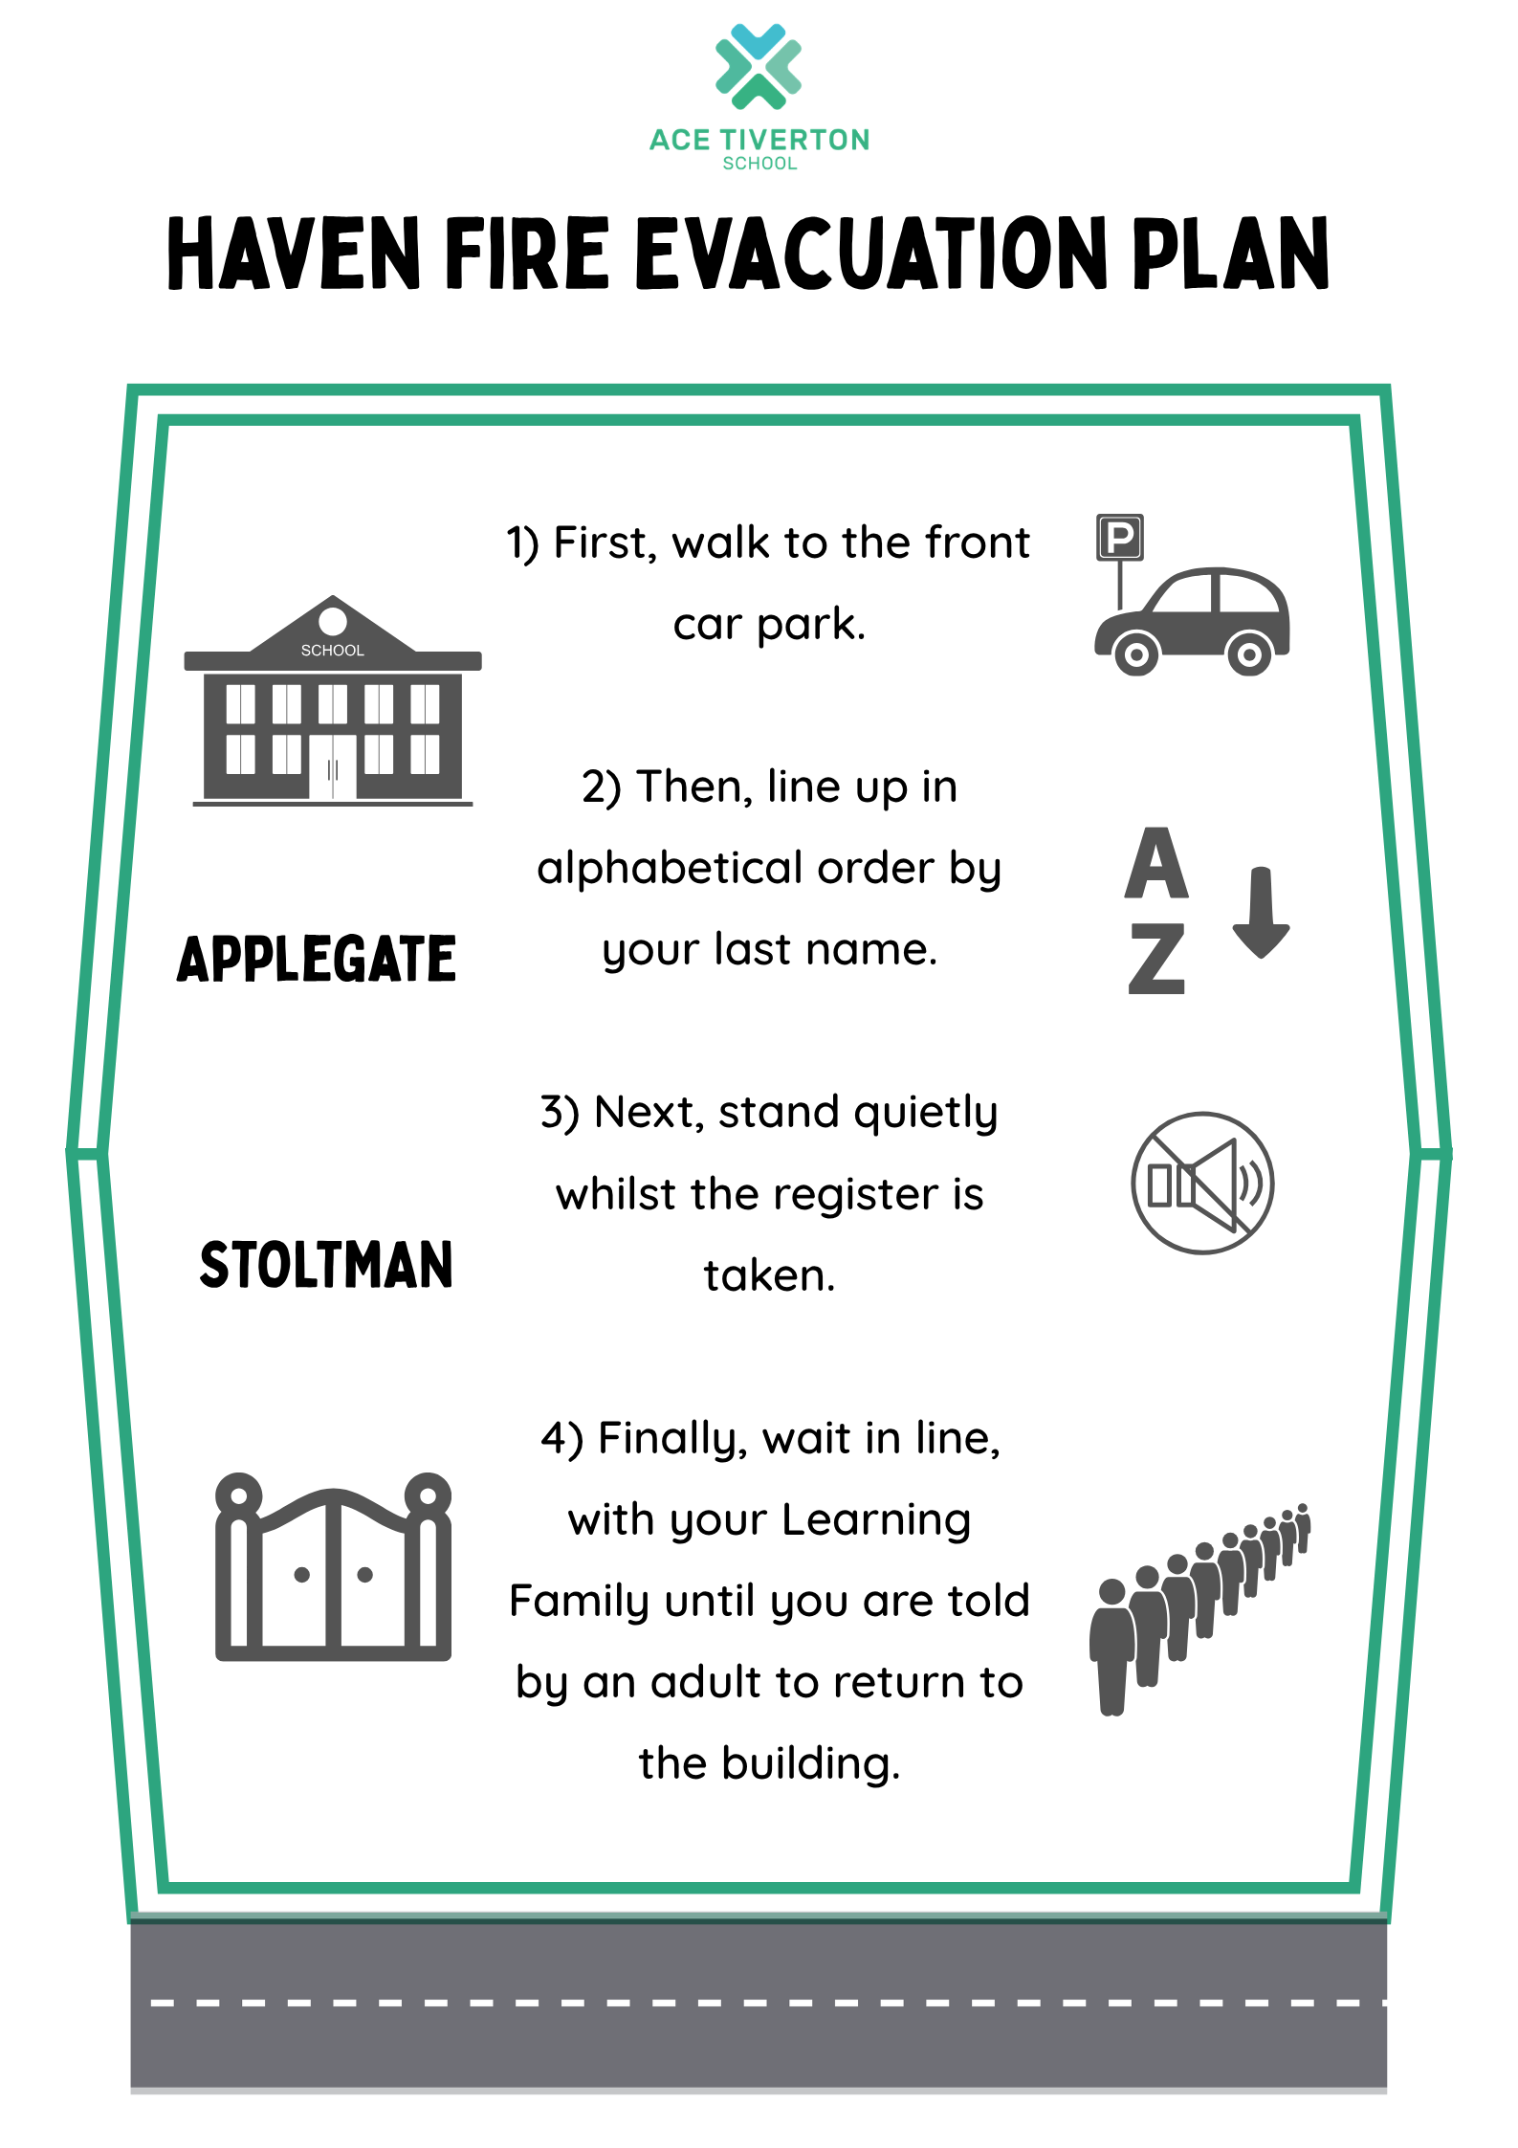


FIRE ALARM PROCEDURES
ON HEARING THE FIRE ALARM, WHICH SOUNDS LIKE A LOUD, CONSTANTLY RINGING BELL

ALL STAFF SUPERVISING STUDENTS WILL:
- Escort their students from teaching areas to the Assembly Point via the nearest fire exit.
- All books, coats and bags etc should be left in the room.
- Shut the door when everyone has left the room.
- If the alarm sounds during a Break/Lunch times, then the students and staff must make their own way to the Assembly Point. Duty staff should supervise evacuation of the building(s) ensuring it is carried out in an orderly manner.
- Ensure students walk quietly and sensibly to the Assembly Point - DO NOT RUN.
- Once you have left the building or your room, do not return until the building has been deemed to be safe.
STUDENTS WILL:
- Leave their classroom in a calm and orderly manner, following the instructions of the supervising adult.
- Leave bags, coats and other items in the classroom or as directed.
- Walk to the assembly point and line up alphabetically in mentor groups.
- Remain silent and orderly throughout the fire alarm.
- Respond to the registers quickly and appropriately.
- Follow instructions given by the mentor or other appropriate adult.
- Leave the fire assembly point as directed in a calm and orderly manner.

If you hear the fire bell sound….

The assembly point is at the front of the school. Go there when you hear the fire bell . Do not take your bags  or coats with you, they will be safe in the building. Walk do not run . Find your class teacher and TA  and say your name for the register  . There are adults in our school who act as our Fire Marshals, their job is to check the building and let us know if it is safe to return or to call the Fire Brigade if we need their help. Stay with

your class teacher or TA until you are told to return to the building.

